

08

Fall

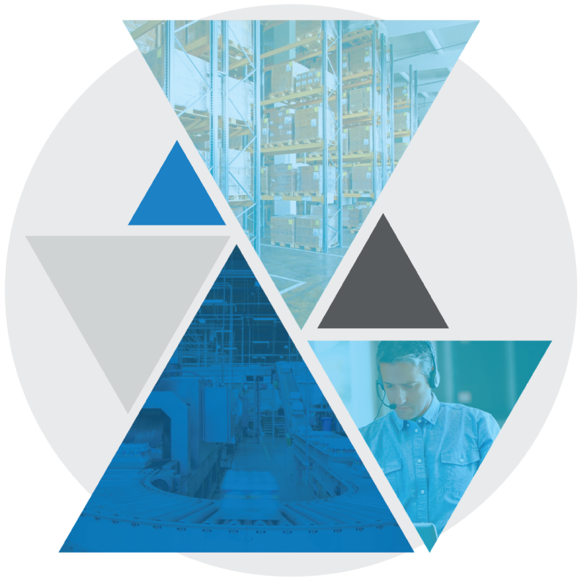

**Test Case: BASE-SHP-1120   
Web Outbound Close Load with Safety Questions**

Table of Contents

Web Outbound Close Load with Safety Questions 3

Test Case Setup 3

Test Case Cleanup 3

Test Case Prerequisites and Assumptions 4

Test Case Examples 4

Test Case Configurations 5

Test Case Verification Approach 5

Test Case Specification 5

Web Outbound Close Load with Safety Questions

This document documents the test case instructions for the BASE-SHP-1120 Bundle Test Case implementing Web Outbound Close Load with Safety Questions.  
  
**Please note**: The inputs used in these test case specifications (defined in the input CSV files or Datastore) are relative to our testing warehouse environment and are provided as examples. These inputs should be substituted with valid inputs relative to your WMS environment.

Test Case Setup

* Test Case Background function will run the standard set of setup scenarios for the bundle.
* Test Case Dataset
  + Checks in trailer
  + Creates and assigns shipment information

Test Case Cleanup

* The Test Case After Scenario will run the standard cleanup actions for the bundle.   
  **NOTE:** This including logging out of all interfaces (Terminal and Web).
* Data created during dataset creation and execution is cleaned up.

Test Case Prerequisites and Assumptions

* Sufficient pickable and shippable inventory is present for the order

Test Case Examples

This Test Case will only perform Web Outbound Trailer Close with safety check questions and will not perform any other examples of this function.

Test Case Configurations

The Test Case will be run in the following test configurations:

* Blue Yonder Web UI
  + Google Chrome
  + Microsoft Edge

Test Case Verification Approach

This test will verify screen data in-line within the test step sections.

Test Case Specification

|  |  |
| --- | --- |
| **Test Case:** BASE-SHP-1120 Web Outbound Close Load with Safety Questions | **Description:** Web Outbound Close Load with Safety Questions **Functional Area:** Loading **Test Case Type:** Regression **Dataset:** Datasets/Base/Web_Outbound_Trailer_common  **Test Case Inputs:** Test Case Inputs/BASE-SHP-1120.csv  **Duration:**  3 minutes |

|  |  |
| --- | --- |
| **Steps, Actions, and Expected Results** | **Supporting information and/or Affected Data** |
| **Step 1**: Sign into the Web UI using your relevant Username and Password  **Actions**:   * Enter Username and Password * Click on the Sign In button   **Expected Results**:   * User successfully logs on to web |  |

|  |  |
| --- | --- |
| **Step 2**: Search for Door Activity Web screen  **Actions**:   * Type ‘Door Activity’ in JDA search field and press ENTER   **Expected Results**:   * Relevant pages should be returned from the search. |  |

|  |  |
| --- | --- |
| **Step 3**: Navigate to Shipping Door Activity Web page  **Actions**:   * Select **Shipping -> Door Activity**   **Expected Results**:   * Door Activity screen is opened |  |

|  |  |
| --- | --- |
| **Step 4**: Click on Trailer/Load to Close  **Actions**:   * Click the Trailer/Load * Click on Actions Button Click on Close Equipment   **Expected Results**:   * *CYC_OBMOV2* is now the only Load featered in the list |  |

|  |  |
| --- | --- |
| **Step 5**: Then I enter Tranposrt Equipment Seal  **Actions**:   * Enter the Transport Equipment Seal   **Expected Results**:   * Seal is Populated |  |

|  |  |
| --- | --- |
| **Step 6**: Save  **Actions**:   * Click the **Save** button located in the bottom left corner   **Expected Results**:   * Transport Equipment Workflow page opens |  |

|  |  |
| --- | --- |
| **Step 7**: Click Yes to Perform Workflow  **Actions**:   * Click on **Yes** Button   **Expected Results**:   * Prompts for Securement Questions |  |
|  |  |
| **Step 8**: Click Yes For Each Question  **Actions**:   * Click **Yes** button for each Safety Question Displayed   **Expected Results**:   * Able to click Yes for all Questions |  |

|  |  |
| --- | --- |
| **Step 9**: Click **Complete** Button  **Actions**:   * Click the **Complete** button located in the bottom left corner   **Expected Results**:   * WMS prompts that transport equipment was closed successfully |  |

|  |  |
| --- | --- |
| **Final State:** Confirmation of shipping desired transport equipment is displayed.  Standard test verification and log off functions are performed |  |